Brett Stelly

Cameras and Projections

**SetLookAt implementation without use of glm**

To set the camera’s viewTransform, you will need a function that takes in three vec3s. The first vec3 is called “from”, and it is the position of the camera. The second vec3 is called “to” and it is the direction to look in. The last vec3 is called “up” and it is a vector that points upwards.



Within the function, you will need to create a vec3 which we will call “forward”. Assign forward the normalized value of from - to. Next, create a vec3 called “right”, and assign it the cross product of the up variable normalized and forward. Then create another vec3 called “_up” and assign it the cross product of forward and right.

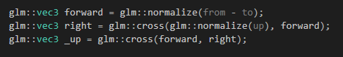

Now, we assign every index in the camera’s viewTransform as shown in the following picture:

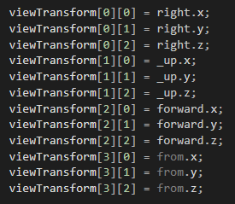

Finally, return the viewTransform.